This document contains screen shot of the junit test cases run on the eclipse IDE for individual test sets

------------------------------------------------------------------------------------------------------------------------------------------

1. Check in the items to the super market :

Test class : com.assignment.ubs.junit.supermarket.SuperMarketClient

Test method :checkinItems

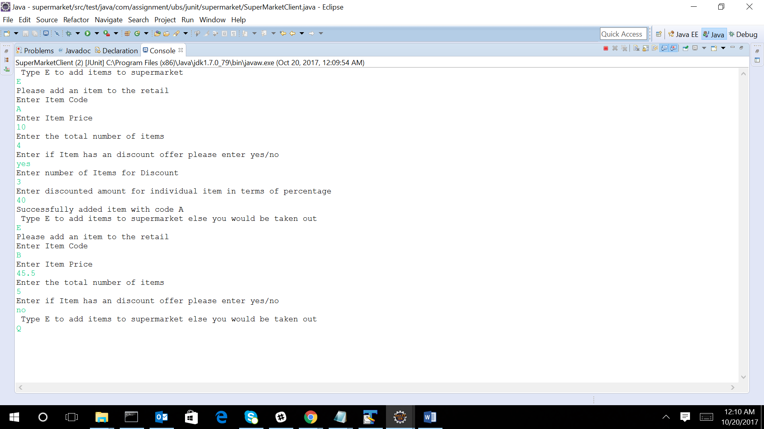

After the running the above test case the super market contains the below items

|  |  |  |  |  |  |
| --- | --- | --- | --- | --- | --- |
| **Item cd** | **Item price** | **Total number of items** | **Discount offer** | **Minimum items reqd for discount** | **Discount amount in percentage** |
| A | 10 | 4 | Yes | 3 | 40 |
| B | 45.5 | 5 | No | None | 0 |

2 . Show catalog :

Test class : com.assignment.ubs.junit.supermarket.SuperMarketClient

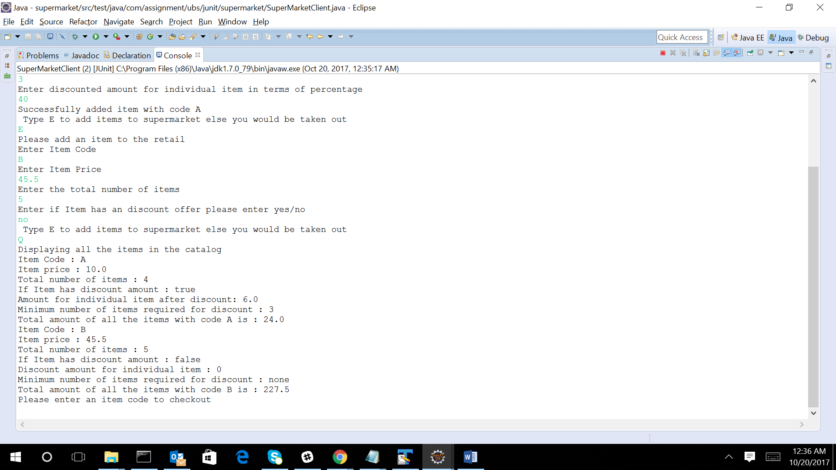Test method: showCatalogItems

1. Checkout of item A:

Test class : com.assignment.ubs.junit.supermarket.SuperMarketClient

Test method: singleItemCheckout

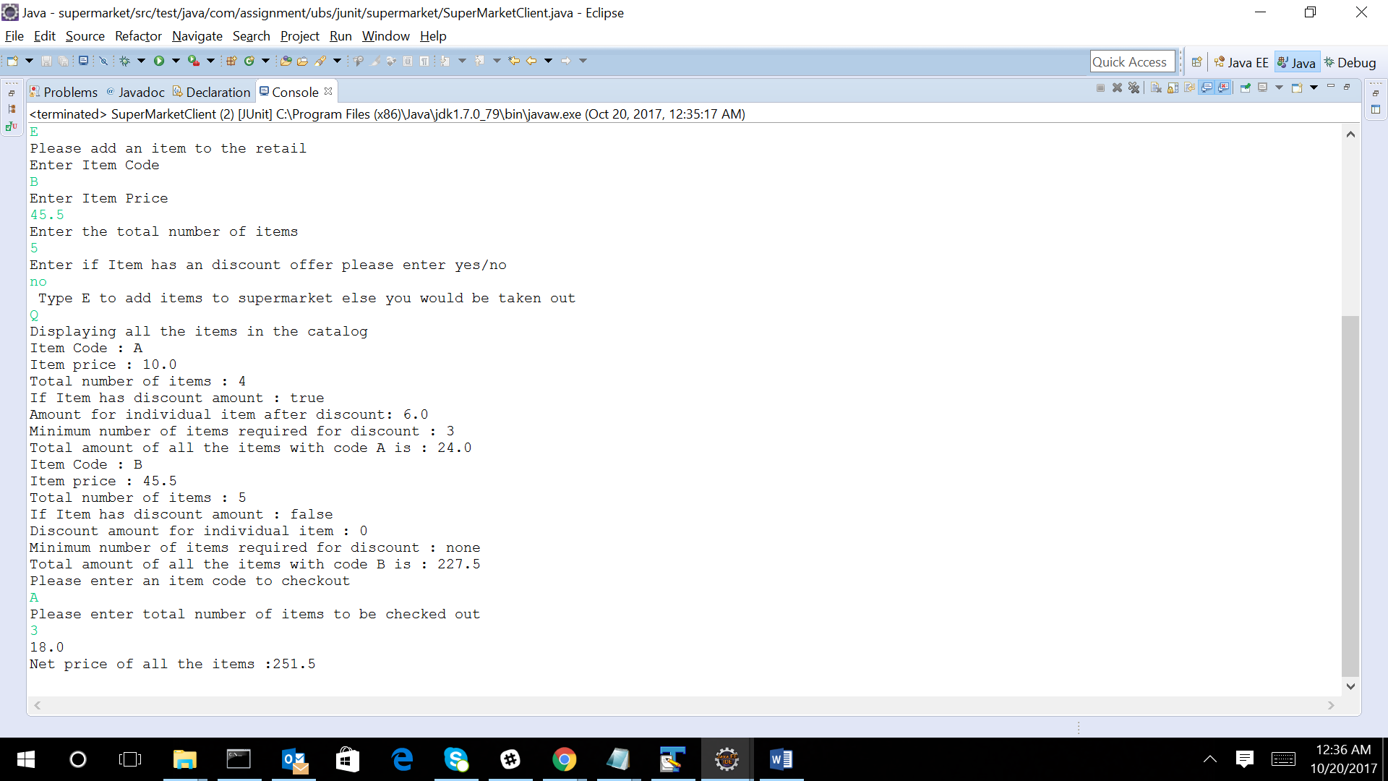

1. Sum of all items :

Test class : com.assignment.ubs.junit.supermarket.SuperMarketClient

Test method:sumOfItemsCheckOut

Result : As seen above its 251.5